R Program on Normal Distribution
#R program for normal distribution
#dnorm(x,m,s)=p(X=x)
#pnorm(x,m,s)=P(X<=x)
1-pnorm(x,m,s)=P(X>x)
Or
pnorm(x,m,s,lower.tail=FALSE)
#qnorm(p1,m,s) used for finding x such that P(X<=x)=p1
#rnorm(n,m,s) generates random sample of size n

Q.1) Generate 5 random numbers from normal distribution with mean =15,SD=4. Also find the mean of those numbers
CODE :
r=rnorm(5,15,4)
r
cat("The 5 random numbers from normal distribution are as followed :- ",r)
m=mean(r)
cat("The mean of those random numbers is ",m)

OUPUT:
r=rnorm(5,15,4)
> r
[1] 20.54469 12.54565 13.21842 16.69213 17.31129
> cat("The 5 random numbers from normal distribution are as followed :- ",r)
The 5 random numbers from normal distribution are as followed :- 20.54469 12.54565 13.21842 16.69213 17.31129> m=mean(r)
> cat("The mean of those random numbers is ",m)
The mean of those random numbers is 16.06243>

Q.2)Let X~N(50,100); Find
1. P(X<=70) 2. P(X>65) 3. P(X<=30) 4. P(35<X<60) 5. P(50<X<65)

CODE :
m=50
s=sqrt(100)
s
p1=pnorm(70,m,s)
cat("p(X<=70)= ",p1)
p2= 1- pnorm(65,m,s)
cat("p(X>65)= ",p2)
p3= pnorm(30,m,s)
cat("p(X<=30)= ",p3)
p4=pnorm(60,m,s)-pnorm(35,m,s)
cat("P(35<x<60= ",p4)
p5=pnorm(65,m,s)-pnorm(50,m,s)
cat("P(50<x<65= ",p5)
OUTPUT:
> m=50
> s=sqrt(100)
> s
[1] 10
> p1=pnorm(70,m,s)
> cat("p(X<=70)= ",p1)
p(X<=70)= 0.9772499>
> p2= 1- pnorm(65,m,s)
> cat("p(X>65)= ",p2)
p(X>65)= 0.0668072>
> p3= pnorm(30,m,s)
> cat("p(X<=30)= ",p3)
p(X<=30)= 0.02275013>
> p4=pnorm(60,m,s)-pnorm(35,m,s)
> cat("P(35<x<60= ",p4)
P(35<x<60= 0.7745375>
> p5=pnorm(65,m,s)-pnorm(50,m,s)
> cat("P(50<x<65= ",p5)
P(50<x<65= 0.4331928>
Q.3)Let X~N(160,400), find k such that p(X<k)=0.6
CODE :
k=qnorm(0.6,160,20)
k
cat("The value of such that p(x<k)= 0.6 is: ",k)
OUTPUT:
> k=qnorm(0.6,160,20)
> k
[1] 165.0669
> cat("The value of such that p(x<k)= 0.6 is: ",k)
The value of such that p(x<k)= 0.6 is: 165.0669>

Q.4)Plot pdf & cdf graph of normal distribution ranging from (-3,3) with common difference of 0.1 ?
CODE:
p=5/100
n=100
m=n*p
p
m
p1=dpois(0,m)
p1
cat("p(x=0)=",p1)
p2
p2=dpois(5,m)
p2
cat("p(5<=5)=",p2)
OUPUT:
> k=qnorm(0.6,160,20)
> k
[1] 165.0669
> cat("The value of such that p(x<k)= 0.6 is: ",k)
The value of such that p(x<k)= 0.6 is: 165.0669>
> x=seq(-3,3,0.1)
> np=dnorm(x)
> plot(x,np,"l",xlab="xvalues",ylab="Normal probability",main="Graph of pdf of standard Normal variable")
> cp=pnorm(x)
> plot(x,cp,"l",xlab="xvalues",ylab="Cumulative probability",main="Graph of cdf of standard Normal variable")
>

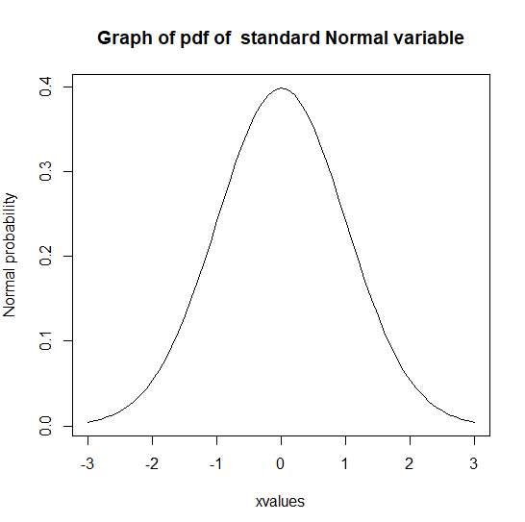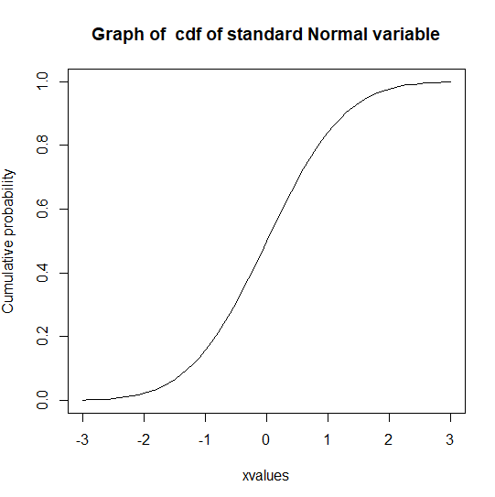

Q5. Plot the graph of pdf and cdf for X~N(3,4) Range (-7,12) common difference 0.1

CODE:
x=seq(-7,12,0.1)
np=dnorm(x,3,2)
plot(x,np,"l",xlab="xvalues",ylab="Normal probability",main="Graph of pdf of Normal variable")
cp=pnorm(x,3,2)
plot(x,cp,"l",xlab="xvalues",ylab="Cumulative probability",main="Graph of cdf of Normal variable")
OUTPUT:
> x=seq(-7,12,0.1)
> np=dnorm(x,3,2)
> plot(x,np,"l",xlab="xvalues",ylab="Normal probability",main="Graph of pdf of Normal variable")
> cp=pnorm(x,3,2)
> plot(x,cp,"l",xlab="xvalues",ylab="Cumulative probability",main="Graph of cdf of Normal variable")
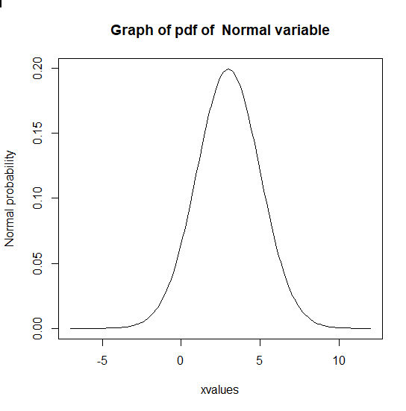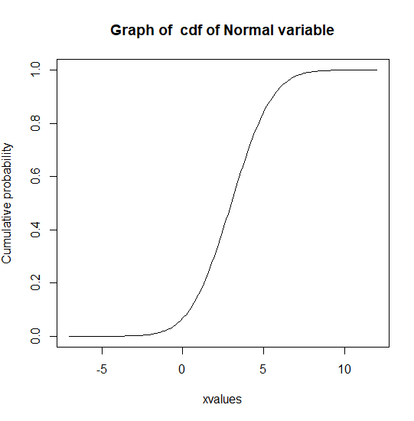
Q.6) The life tme of a battery is normally distributed with a mean life of 40 hours and a standard deviation of 1.2 hours. Find the probability that a randomly selected battery last longer than 42 hours.
CODE:
m=40
s=1.2
p1= 1- pnorm(42,m,s)
cat("p(X>42)= ",p1)

OUTPUT:
> m=40
> s=1.2
> p1= 1- pnorm(42,m,s)
> cat("p(X>42)= ",p1)
p(X>42)= 0.04779035>

Q.7) Scores on an IQ test are normally distributed. If the test has a mean of 100 and SD of 10, What is the probability that a person who takes the test will score between 90 and 110.
CODE:
m=100
s=10
p1=pnorm(110,m,s)-pnorm(90,m,s)
cat("P(90<x<110)= ",p1)

OUTPUT:
> m=100
> s=10
> p1=pnorm(110,m,s)-pnorm(90,m,s)
> cat("P(90<x<110)= ",p1)
P(90<x<110)= 0.6826895>

